**AHM PhD SEMINAR SERIES**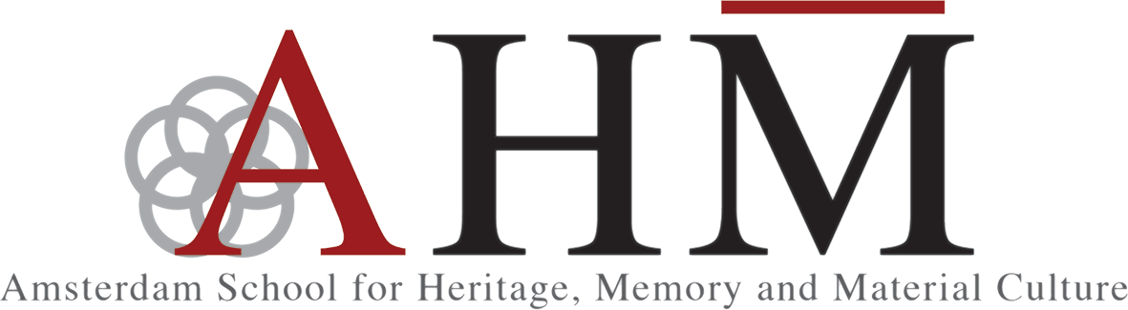

***Rethinking Heritage, Memory & Material Culture***

*Wednesday 7 December 2016, 16:00-18:00*

*Potgieterzaal, Universiteitsbibliotheek*

**Program**  
16:00–16:10 Introduction

16:10–16:30 Presentation **NOORTJE DE LEIJ**, **PHD Candidate, ASCA**

**Reflections on the Dialectics of Seeing**

16.30 -16.50 Presentation **DUSAN BAROK**, **PhD Candidate, AHM**

**Databases and Archives**

16:50–17:10 Response: Prof. Robin Boast

17:10–18:00 GROUP Discussion

In the first session of *Rethinking Heritage, Memory Studies and Material Culture (AHM PhD Seminar Series)*, we focus on experience and epistemology against an expanding prevalence of digitality. The starting point for this seminar is a question art critic Hal Foster posed in his 1996 essay: does electronic information--the “archive without museum”--allow for a new dialectics of seeing or is it a mere base of data, a repository of the given? Photographic reproduction has long challenged the status of the art object. For Walter Benjamin, it strips art of context, shatters tradition, liquidates aura and in consequence represents a definitive rupture of the museum. For André Malraux, on the other hand, photography implies the museum’s indefinite expansion and provides the means to reassemble the broken bits of tradition into one metatradition of global styles, a new museum without walls. Yet, in their quest to extend their reach and impact, museums continue to digitize their collections and transform artifacts into data set free to circulate online. Does this dialectic still apply to our situation when electronic archives tend to provide the mnemonic experience, split from the visual one, taken up by the museum as a site of exhibition-form of art and spectacle architecture?

About ***Rethinking Heritage, Memory Studies and Material Culture (AHM PhD Seminar Series)***

AHM fosters an interdisciplinary research of heritage and memory and material culture and brings together researchers working in diverse areas, methods and fields. Given this dynamic juxtaposition, the AHM PhD community will convene a monthly working seminars where PhDs and early stage researchers share, discuss and rethink their work in progress and simultaneously question key elements of contemporary research. In order to open new debates, the seminar sessions will be organized thematically and relate presentations to specific concepts from heritage, memory and material culture. The seminar’s interdisciplinary approach is meant to encourage dialogue across disciplines and practices and includes a response by a senior scholar as a discussant. Such informal setting hopefully will encourage re-configurations of existing research perspectives, encourages critical feedback on work -in-progress and the wider methodological approach of the speakers. Each session will include prior reading recommendations in order to complement group discussion.

*For registration and further inquiries, please contact: Dana Dolghin,(D.F.Dolghin@uva.nl).*

*AHM PhD Seminar Series are open to all university PhD candidates and staff. This Seminar series is organized by the Amsterdam School of Heritage, Memory and Material Culture (AHM). Seminar Series Coordinators: Dr. Ihab Saloul & Dana Dolghin.*